

***COURSE*: FUNDAMENTAL OF MARKETING**

***LECTURER*: ANN RINTARI**

***TASK*: PRODUCT LIFE CYCLE A COCA**

**COLA CASE STUDY**

***GROUP:* GROUP 7**

***GROUP MEMBERS*:**

**Natasha Johnson -657055**

**Afeez Ogundipe –650522**

**Patel Vidhi k -655586**

**Evelyn A. Adie -653045**

**Tracy Wanjiru –650549**

**Evans Kimathi -652210**

**INTRODUCTION TO COCA COLA**

The product life cycle is the journey that most recognized products undergo to be recognized and cherished. The product life cycle is composed of introduction, growth, maturity and finally decline. The Introduction stage is the initial stage, it mainly is comprised with the firm trying to build awareness and develop market for its product, It’s then followed by growth stage where after their brand has been identified the firm tries to build its preference and increase market share, from growth stage we are seamlessly drawn into maturity stage where strong growth in sales diminishes because of arising of new competition and their main focus becomes trying to defend market share while maximizing profit. Finally there is the decline stage and this is where the company is forced to make the hardest decisions such as whether to remain in the same market share or pivot.

For our case study we choose to use one of the most successful companies in the world Coca-Cola. Recognized for its dark fizzy and chilling drink, it’s globally recognized and has grossed over 8.25 Billion US dollars as of 2018.

Coke begun in 1895, when a former confederate colonel, who was hurt and developed a syrup formula to ease up his pain and for his fellow, hurt soldiers as a replacement for morphine. He created coca cola from the coca plant which is also synonymous with cocaine the mind altering plant that was planted in huge amounts in South America and mixed it with alcohol at the time. When the prohibition period finally arrived he was forced to pivot and come up with a better mixture that did not have alcohol within it.

Mr. Pemberton pitched the drink as all of elixir that cured nerve disorders, headaches and other body pains. Due to the usage of the coca plant he thus came up with the name coca cola and he later sold the rights to the mixture to a successful business man called Asa Candler who formed a corporation to produce the beverage in large scale.

Mr. Asa was a marketing genius and came up with new and innovative ways to promote the product and as new people started to discover this refreshing beverage very soon it was dispersed all over the America. It was only served from soda fountains until the year 1916 when coca cola finally released their infamous contour bottle that had a distinct shape and could be recognized from a far.

In 1919 Mr. Asa sold the company to a couple of investors who appointed the Robert woodruffs as the chairman. Mr. Woodruff later propelled coca cola to new heights by opening bottling plant all over the world making coca cola the first global company to exist and having multiple companies globally.

Fast forward to the future coca cola is globally acknowledged in 200 countries and served to people of all walks of life it has been able to market itself as a feeling rather than just a product and due to this resonance it has been able to capture the hearts of people which has then led to it making its high profits.

**1.INTRODUCTION STAGE**

The introduction stage of any product is the most important in the whole journey because it set the standard and pace of how all the other stages will move on. For coca cola this was noticed very early with a specific pain point, to quench the thirst of people using a sweet and characteristically dark beverage it was virtually impossible for DR john pemberton to get this wrong. Creating flavored syrup, out of carbon water, alcohol and touches of cocaine. He first tested it in the pharmacy and the few who had the first drink were completely smitten by it and it became a straight hit in the neighborhood.

Dr s pemberton sought investment for mass production from a bookkeeper named Frank M. Robinson. Their relationship grew and they were able to come up with a catchy name for the drink and named it coca cola. On May 8, 1886 initial sale begun with a glass of the drink going for 5cents and they were able to accrue average of 9 drinks per day and they were able to sell 25 gallons of syrup.

Dr s pemberton transferred the rights of the coca cola drink to Asa.G.Candler who later went on to become the mayor of Atlanta. Candler was a ingenious marketer and came up with innovative methods of marketing the drink from designing the logo by hand to packaging in red barrels labeled with the coca cola logo for distribution and for the biggest achievement in coca cola he was able to accept the bottling of coca cola for people who wanted to consume the drink from the comfort of their houses.

It was firstly marketed as a cure for all elixir but as time passed the narrative changed to beverage recreational drink in 1898 and distributions started popping all over the world their outstanding bottle shape and logo acted as distinct identifiers which built customer loyalty and has propelled the brand success to date.

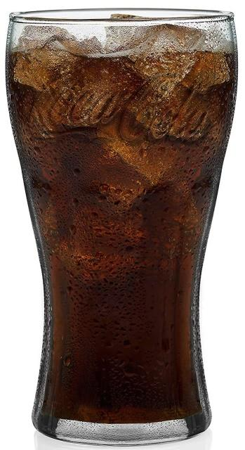

**2. GROWTH STAGE**

The growth stage in the product life cycle is a period of rapid revenue growth. As product awareness increases, customers are more likely to purchase the item and sales increase. The success of a product in one area can lead to the product being introduced into other market segments. A continued increase in sales can lead to additional demand and further sales. During the growth stage, competing products may be introduced by other companies. This can lead to price competition and additional costs in advertising to maintain the demand for the product at the expense of the competition.

**Growth**

The concept of growth is remarkably simple. Essentially, a company is experiencing growth when it’s profits and market share grow. So let’s take a look at Coca-Cola, is it growing? According to that referenced Investopedia article, maybe not. Both companies face competition from the growing market of healthier alternatives to sugary soda drinks, such as energy and nutritional drinks. This has reduced Coke's operating margin from about 25% to approximately 20% since the year 2000. To adjust to these changing market conditions, both Coca-Cola and Pepsi have developed their own alternative beverages but still face competition and market share erosion from other competitors. So what does this mean? The most important part of this quote is that Coca-Cola and Pepsi are facing competition. More importantly, they are facing “market share erosion from other competitors.” Is this consistent with our previous definition of growth? (A company is experiencing growth when it’s profits and market share grow.)

The Growth Stage

• Coca-Cola is currently in this stage.

• To extend it's mature stage Coca-Cola has developed the following marketing strategies: product improvement, new models were developed, it entered new market segments, and enlarged its distribution channels

• Increasing sales, more competitors, and higher profits.

• Competitors are beginning to enter the market more rapidly.

• Number of distribution outlets begin to increase.

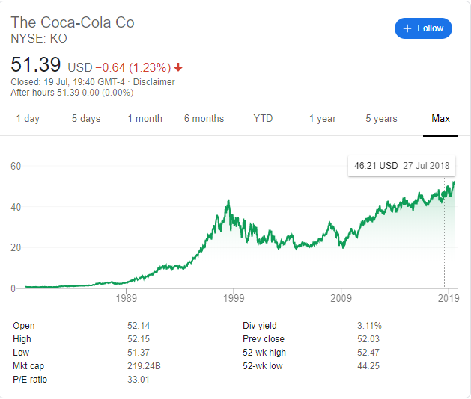

**3.MATURITY STAGE**

The next stage after growth is maturity. The third stage of the product life cycle stages can be a challenging time for manufacturers. In the first two stages companies try to create a market and then grow sales of their product to achieve as large a share of that market as possible. However, during the Maturity stage, the key focus for most companies will be maintaining their market share in the face of a number of different challenges.

**CHARACTERISTICS**

Sales growth slows down - when the product is mature, most of the targeted customers already have the product therefore, after the steady increase in sales during the Growth stage, the market starts to become saturated as there are fewer new customers. The majority of the consumers who are ever going to purchase the product have already done so.

Increased competition -The Company will want to prolong this phase so as to avoid decline, and this will lead to new innovation and features to continue to compete with the competition which, by now, has become very established, advanced and fierce. Competitor’s products will begin to cut deeply into the company’s market position and market share.

Profits Start to Decrease- Profits will have to be shared amongst all of the competitors in the market, and with sales likely to peak during this stage, any manufacturer that loses market share, and experiences a fall in sales, is likely to see a subsequent fall in profits. These decrease in profits could be compounded by the falling prices that are often seen when the complete number of competitors forces some of them to try attracting more customers by competing on price.

**Example of coca cola at the maturity stage**

Coca-Cola is a great example of a product that has had a very long product life cycle. Since being introduced in 1886, it has spent the majority of its life in the maturity stage. During this stage, coca cola had developed new marketing strategies.

Product improvement – coca cola improves its products in order to satisfy their customers and retain customers. They improved coke by producing drinks with less sugar and no sugar. For example; diet coke and coke zero for people who consume less or no sugar.

Enters a new market – coca cola has already divided its broad target market into subset of Consumers, Businesses or countries who have common needs etc. however, coca cola later on divides its buyers into different groups on the basis of lifestyle or personality or values to get closer to the customers.

New advertising strategies – coca cola is known for having the best advertisements. They come up with new ideas constantly to keep the audience aware about its existence and attract customers. Example is the festive season advert, coke studio sessions which is for entertaining its customers and also an innovative way of attracting and retaining customers. Also, coke was awarded for advertising innovation.

**PRICING STRATEGY**

Businesses usually use the competitive pricing strategy at the maturity stage. Competitive pricing consists of setting the price at the same level as one's competitors. It is setting the price of a service or product based on what the competition is charging. It is much more than just possessing an overall idea of the prices charged by competitors for services or products. Businesses consider cutting prices to attract customers however, don’t go below the break-even point. They use this strategy due to increased competition hence to gain customers.

Another strategy firms use is discount pricing strategy. Businesses use discount pricing to sell low-priced products in high volumes. When using this strategy, it is important to decrease costs and stay competitive. Large retailers are able to demand price discounts from suppliers and make a discount pricing strategy effective as they buy in bulk.

**4.DECLINE STAGE**

Decline stage is when the product life cycle is at its most terminal stage and sales drop either due fierce competition or financial uncertainty amongst customers this might even lead to halting of production if it continuously persists.

Coca-Cola being a great company with international recognition and robust growth its wonderful how it’s been able to remain at maturity stage for this long.

Publicly available information about individual brands that Coca-Cola company difficult to come by, But we will use the publicly available info that is there.

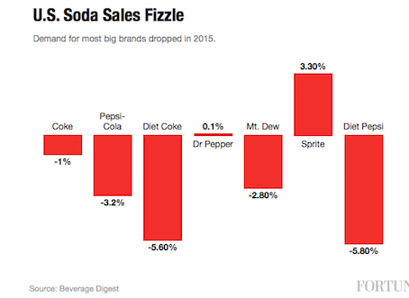

As can be seen, the only brand with a significant increase was Sprite. I was puzzled by this as I was unaware of any particular marketing campaign. But in the US, Sprite has included quotes from hip-hop stars on their cans and this seems to be resonating with their target market.

There are a few different reasons for the decline of a product:

* Competitors’ products are getting more attention than yours
* Consumers are no longer interested in the product
* You aren’t profiting off the product anymore

*Pricing strategy in this stage:* During a product’s decline, many businesses choose to lower its price. In fact, there are a few different pricing strategies you can try in this stage.

You can try a discount pricing strategy to increase customer traffic. This will help free up space at your business for new products.

Another pricing strategy option is bundling. With bundling, you could include the declining product in a deal with other products. This can help get rid of the declining product and increase sales.

Be aware that some businesses choose to do nothing during the decline stage, especially if they are unsure if the product is declining for good or just going through a temporary dip in sales

**REFERENCES**

1. Andreeva, A. (2016, october 23). the product life cycle of coca cola. *Prezi*. Retrieved from https://prezi.com/5wrie3bddyxs/the-product-life-cycle-of-coca-cola/
2. maturity . (n.d.). *product life cycle stages* . Retrieved from http://productlifecyclestages.com/product-life-cycle-stages/maturity/
3. C. C. (2018, February/March). Coca-Cola History. Retrieved July 22, 2019, from <https://www.worldofcoca-cola.com/about-us/coca-cola-history/>
4. B. C. (2016, August 26th April 2016). Coca-Cola and the decline stage of the PLC: Business. Retrieved July 22, 2019, from <https://www.tutor2u.net/business/blog/coca-cola-and-the-decline-stage-of-the-plc>
5. Gitman, L. J., McDaniel, C., Shah, A., Reece, M., Koffel, L., Talsma, B., & Hyatt, J. C. (2018, September 18). Coca cola Growth stage. Retrieved July 22, 2019, from https://opentextbc.ca/businessopenstax/chapter/the-product-life-cycle/